**Mingle:An Office Networking Platform**

Team:

Gauri Sarode: gss383

Joby Joy: jj2196

Mingle is an application that allows all the employee to connect and update each other with their existing projects, form teams to contribute to projects, update their skills and interest in their profiles, add certifications, share pictures and location of the conferences,events and socialize with other employee across the firm.

Following are the functionalities of the system:

**Create/Register a Mingle profile:**

All employee’s of the organization are allowed to create a profile on Mingle. The employee can make the profile public or private upon his discretion. Once the employee deletes his profile, all the data corresponding to the employee profile will be deleted.

**Create or Update Posts on the Wall:**

Employees can create and update posts on their wall. The posts can be anything specific to the employee. Examples of which can be all the courses that he is takes, his views on modern technologies, hotlinks to his github repository, twitter handle etc. He can also create post specific to the project and provide his team explicitly to view the content.

**Network and build relationships:**

Mingle allows an employee to network and collaborate with other employees by sending a connect request. An employee can also use Mingle to form teams and collaborate with the team members in project activities. Connection can be team, friends or distinct friends given the scenario.

**Upload Multimedia Contents:**

Employees can post pictures, videos etc of presentation, conferences, training resources with Mingle providing the provision to either share it across team or across the organization.

**Adding Location details and Comments :**

Employees can post their location details on Mingle that allows others to know where you are. This feature can be used when the employee attends a event and would like to showcase his presence across the organizations. Mingle allows an employee to comment on post and also allows him to make the comment restricted to Team or Public .

**Likes:**

Employees can like posts, comment or multimedia contents posted by an employee.

**Database Requirements:**

Mingle will be designed as a relational database application which will be using MySQL as its database server.

*MySQL version:*

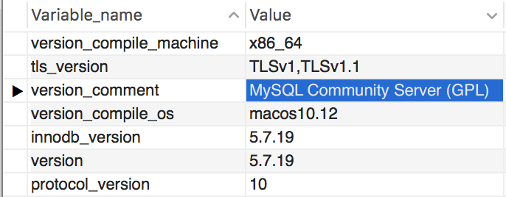

*Entity Relationship Diagram:*

*Assumptions:*

* Every employee is assigned a level between A to D where A refers to Junior associates, B refers to senior associates, C refers to managers, D refers to CEO, President, Trustee. By default a new employee is assigned the level A following which the HR assigns the corresponding level based on their skills and experience.
* Access id are allowed at the profile and post level.
* Access id’s can be S: Self, T: Team, F: Friends, FOF : Friend and Friends of Friends, P: Public.
* Realation_type in the relationship table indicates the type of friendship, F: Friends, FOF: Friend of Friends, T: Team.

*Relational Schema:*

* employee(**ssn,**email_id)
* signin(ssn,password)
* registered_employee(**profile_name**,ssn,first_name,last_name,address,designation,skills,interests,manager,level,access_id,email_id,profile_pic,gender)
* post(**post_id**,post_date,post_title,post_desc,access_id)
* wall(post_id,profile_name)
* relationship(sender_name,receiver_name,relation_type,request_time,request_status)
* multimedia_content(**multimedia_id**,post_id,multimedia_name,multimedia_type, multimedia_content,access_id)
* comment(**comment_id**,post_id,desc,comment_date,commentor_name,access_id)
* location(**loc_id,**post_id,name,description,latitude,longitude,access_id)
* likes(**like_id**,post_id,comment_id,multimedia_id,loc_id,viewer_name,like_date)

*Foreign Keys:*

* ssn in signin table is a foreign key referencing the ssn in the employee table.
* ssn in the registered_employee table is a foreign key referencing the ssn in employee table.
* post_id,profile_name in wall table references the post_id in post and profile_name in the registered_employee table respectively.
* In multimedia_connent table post_id is the foreign key referencing table post.
* In comment table post_id is the foreign key referencing table post and commentor_name is the foreign key referencing table registered_employee.

* In like table likes viewer_name is the foreign key referencing table registered_employee and post_id is the foreign key referencing table post and multimedia_id is the foreign key referencing table multimedia_content and loc_id is the foreign key referencing table location.
* In relationship table sender_name references table registered_employee.

**DDL Statements:**

create database Mingle;

use Mingle;

drop table if exists employee;

#Create employee table

create table employee(

ssn int primary key, email_id varchar(20) not null

);

#Create sign in table

drop table if exists signin;

create table signin

(

ssn int unique,

password varchar(50) not null,

foreign key (ssn) References employee(ssn)

on delete cascade

);

#Create registered_employee table

drop table if exists registered_employee;

create table registered_employee

(

profile_name varchar(30) primary key,

ssn int unique,

first_name varchar(20) not null ,

last_name varchar(20) not null,

address varchar (255),

designation varchar(20),

skills varchar(255),

interests varchar(255),

manager varchar(20),

level enum('A','B','C','D') default 'A',

email_id varchar(50),

profile_pic blob,

gender enum('Male','Female'),

access_id enum('P','T','F','S','FOF') default 'S',

foreign key (ssn) References employee(ssn)

on delete cascade

);

#Create post

drop table if exists post;

create table post

(

post_id varchar(30),

post_time timestamp not null,

post_title varchar(150),

post_desc varchar(255),

access_id varchar(5) default 'S',

primary key (post_id)

);

#Create wall(post_id,profile_name)

drop table if exists wall;

create table wall

(

post_id varchar(20),

profile_name varchar(30),

foreign key (profile_name) references registered_employee(profile_name)

on delete cascade

on update cascade,

foreign key (post_id) references post(post_id)

on delete cascade

on update cascade

);

#Create relationship table

drop table if exists relationship;

create table relationship

(

sender_name varchar(30),

receiver_name varchar(30),

relation_type varchar(20),

request_time timestamp,

friendship_status varchar(20) NOT NULL,

foreign key (sender_name) references registered_employee(profile_name)

on delete cascade

on update cascade,

foreign key (receiver_name) references registered_employee(profile_name)

on delete cascade

on update cascade,

primary key(sender_name,receiver_name)

);

#Create multimedia table

drop table if exists multimedia_content;

create table multimedia_content

(

multimedia_id varchar(10) primary key,

post_id varchar(20),

multimedia_name varchar(20),

Multimedia_type varchar(20),

multimedia_content blob,

access_id varchar(5) default 'S',

foreign key (post_id) references post(post_id)

on delete cascade

on update cascade

);

#Create table Comment

drop table if exists comment;

create table comment

(

comment_id varchar(20) primary key,

post_id varchar(20),

comment_desc varchar(255),

comment_date datetime,

commentor_name varchar(30),

access_id varchar(5) default 'S',

foreign key (commentor_name) references registered_employee(profile_name)

on delete cascade

on update cascade,

foreign key (post_id) references post(post_id)

on delete cascade

on update cascade

);

#Create location table

drop table if exists location;

create table location

(

loc_id varchar(20) primary key,

post_id varchar(20),

name varchar(100),

description varchar(255),

latitude varchar(30),

longitude varchar(30),

access_id varchar(5) default 'S',

foreign key (post_id) references post(post_id)

on delete cascade

on update cascade

);

#Create like table

drop table if exists likes;

create table likes

(

like_id varchar(20) primary key,

post_id varchar(30),

multimedia_id varchar(10),

comment_id varchar(20),

loc_id varchar(20),

viewer_name varchar(20),

like_time datetime,

foreign key (post_id) references post(post_id) on delete cascade on update cascade,

foreign key (multimedia_id) references multimedia_content(multimedia_id) on delete cascade on update cascade,

foreign key (comment_id) references comment(comment_id) on delete cascade on update cascade,

foreign key (loc_id) references location(loc_id) on delete cascade on update cascade,

foreign key (viewer_name) references registered_employee(profile_name) on delete cascade on update cascade

);

**Procedures :**

DELIMITER $$

#Procedure 1- Insert into employee table

CREATE DEFINER=`root`@`localhost` PROCEDURE `insert_employee`(

IN e_ssn int,

IN e_email varchar(20)

)

BEGIN

INSERT INTO employee

(

ssn,

email_id

) Values

(

e_ssn,

e_email

);

END $$

#Procedure 2: insert into signin table

CREATE DEFINER=`root`@`localhost` PROCEDURE `insert_signin_details`(

IN e_ssn int,

IN e_password varchar(50)

)

BEGIN

INSERT INTO signin

(

ssn,

password

) Values

(

e_ssn,

e_password

);

END $$

#Procedure 3: for inserting registered user

DROP PROCEDURE IF EXISTS `insert_registered_employee` $$

CREATE DEFINER=`root`@`localhost` PROCEDURE `insert_registered_employee`(

IN profile_name varchar(30),IN ssn int,

IN first_name varchar(20),IN last_name varchar(20),IN address varchar(255),IN designation varchar(20),

IN skills varchar(255),IN interests varchar(255),IN manager varchar(20),

IN level enum('A','B','C','D'),IN email_id varchar(50),

IN profile_pic blob,IN gender enum('Male','Female'),

IN access_id enum('P','T','F','S','FOF')

)

BEGIN

INSERT INTO registered_employee

(

profile_name,ssn,first_name, last_name,address,designation,skills,

interests,manager,level, email_id, profile_pic,gender,access_id

) Values

(

profile_name,ssn,first_name,last_name,address,designation,skills,interests,manager,level,

email_id,profile_pic,gender,access_id

);

END $$

#Procedure 4: for inserting post

CREATE DEFINER=`root`@`localhost` PROCEDURE `insert_post`(

IN post_id varchar(30), IN post_time timestamp,

IN post_title varchar(150),IN post_desc varchar(255),

IN access_id varchar(3)

)

BEGIN insert into post

(

post_id,post_time,post_title,post_desc,access_id

) values

(post_id,post_time,post_title,post_desc,access_id

); END $$

#Procedure 5: saving records to wall

CREATE DEFINER=`root`@`localhost` PROCEDURE `add_to_wall`(

IN post_id varchar(20),

IN profile_name varchar(30)

)

BEGIN insert into wall

(

post_id ,

profile_name

)

values(post_id, profile_name

);

END $$

#Procedure 6 request to connect with colleagues

CREATE DEFINER=`root`@`localhost` PROCEDURE `insert_relationship`(

p_sender_name varchar(30),

p_receiver_name varchar(20),

p_relation varchar(20),

p_time_request_sent timestamp,

p_request_status enum('Accepted','Declined')

)

BEGIN

insert into relationship (

sender_name , receiver_name , relation_type,

request_time, request_status

)

Values

(p_sender_name , p_receiver_name , p_relation , p_time_request_sent, p_request_status

);

END $$

#Procedure 7 insert multimedia contents

CREATE DEFINER=`root`@`localhost` PROCEDURE `insert_multimedia`(

IN p_multimedia_id varchar(10),

IN p_post_id varchar(20),

IN p_multimedia_name varchar(20),

IN p_multimedia_type varchar(20),

IN p_multimedia_content blob,

IN p_access_id varchar(5)

)

BEGIN insert into multimedia_content

(

multimedia_id, post_id, multimedia_name,

multimedia_type,

multimedia_content, access_id

) values

(

p_multimedia_id, p_post_id, p_multimedia_name, p_multimedia_type,

p_multimedia_content, p_access_id

); END $$

#Procedure 8 insert comments

CREATE DEFINER=`root`@`localhost` PROCEDURE `insert_comments`(

IN comment_id varchar(20),IN post_id varchar(20),

IN comment_desc varchar(255), IN comment_date datetime,

IN commentor_name varchar(30),

IN access_id varchar(5)

)

BEGIN insert into comment

(

comment_id,

post_id, comment_desc, comment_date, commentor_name,access_id

)

values(

comment_id, post_id,

comment_desc, comment_date, commentor_name, access_id

); END $$

#Procedure 9: inserts location

CREATE DEFINER=`root`@`localhost` PROCEDURE `insert_locations`(

IN loc_id varchar(20),IN post_id varchar(20),

IN lname varchar(100),In description varchar(255),

IN latitude varchar(30), IN longitude varchar(30),

IN access_id varchar(5)

)

BEGIN insert into location

(

loc_id, post_id,name,description, latitude,longitude,access_id

)

values (

loc_id,post_id,lname,

description,latitude,longitude,access_id

); END $$

#Procedure 10:inserts likes

CREATE DEFINER=`root`@`localhost` PROCEDURE `insert_likes`(

IN p_like_id varchar(20),IN post_id varchar(30),IN p_multimedia_id varchar(10),

IN p_comment_id varchar(20), IN p_loc_id varchar(20),

IN p_viewer varchar(20), IN p_like_time datetime

)

BEGIN insert into likes (

like_id, post_id,

multimedia_id,comment_id,loc_id,

viewer_name,like_time

) values

(

p_like_id,post_id,p_multimedia_id,

p_comment_id,p_loc_id,

p_viewer,p_like_time

); END $$

#Procedure 11: Read from registered employee table

CREATE DEFINER=`root`@`localhost` PROCEDURE `registered_employee_acc`()

BEGIN select * from registered_employee;

END $$

#Procedure 12 :Read posts

CREATE DEFINER=`root`@`localhost` PROCEDURE `read_posts`()

BEGIN select * from post;

END $$

#Procedure 13 : Read wall

CREATE DEFINER=`root`@`localhost` PROCEDURE `read_wall `()

BEGIN select * from wall;

END $$

#Procedure 14: Read relationships

CREATE DEFINER=`root`@`localhost` PROCEDURE `view_relationship`()

BEGIN select * from relationship;

END $$

#Procedure 15: View Multimedia Contents

CREATE DEFINER=`root`@`localhost` PROCEDURE `multimedia_contents`()

BEGIN select * from multimedia_content;

END $$

#Procedure 16

CREATE DEFINER=`root`@`localhost` PROCEDURE `comment`()

BEGIN select * from comment;

END $$

#Procedure 17: View Location

CREATE DEFINER=`root`@`localhost` PROCEDURE `location`()

BEGIN select * from location;

END $$

# Procedure 18: View likes

CREATE DEFINER=`root`@`localhost` PROCEDURE `likes`()

BEGIN select * from likes;

END $$

#Procedure 19: View employee table

CREATE DEFINER=`root`@`localhost` PROCEDURE `employee_acc`()

BEGIN select * from employee;

END $$

#Procedure 20: View sign_in table

CREATE DEFINER=`root`@`localhost` PROCEDURE `employee_signin`()

BEGIN select * from signin;

END $$

DELIMITER ;

**Update Procedure:**

DELIMITER $$

DROP PROCEDURE IF EXISTS `update_post_table` $$

# Update Post Table

CREATE DEFINER=`root`@`localhost` PROCEDURE `update_post_table`

(

IN post_id varchar(30), IN post_time timestamp,

IN access_id varchar(3)

)

BEGIN

update post

set post_time= post_time,access_id = access_id

where post_id = post_id;

END $$

DELIMITER ;

**Functions:**

DELIMITER $$

#Function: To check for a new or an existing employee

DROP FUNCTION IF EXISTS `validate_user` $$

CREATE DEFINER=`root`@`localhost` FUNCTION `validate_user`(

e_ssn int

)

RETURNS varchar(50)

BEGIN

DECLARE check_employee varchar(50);

select ssn into check_employee from signin where ssn=e_ssn;

if check_employee!='NULL' Then

return ("Employee subscribed to Mingle");

else

return ("New user registration. You have to sign up first!!");

end if;

END $$

DELIMITER ;

select validate_user(742347663) as Status;

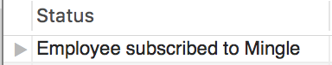

select validate_user(542347663) as Status;

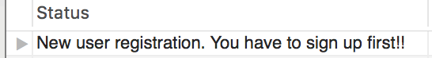

**Test Data.**

Creating test data as part of the test framework for Mingle.

*Insert into employee*

call insert_employee(742347663,'jj2196@nyu.edu');

call insert_employee(742347661,'gss383@nyu.edu');

call insert_employee(378092902,'pns234@nyu.edu');

call insert_employee(407840577,'akk198@nyu.edu');

call insert_employee(940237837,'ryk123@nyu.edu');

call insert_employee(379486342,'gpn967@nyu.edu');

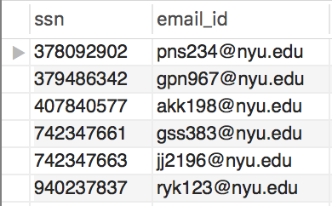

*Insert into signin*

call insert_signin_details(742347663,'password');

call insert_signin_details(742347661,'password');

call insert_signin_details(378092902,'password');

call insert_signin_details(407840577,'password');

call insert_signin_details(940237837,'password');

call insert_signin_details(379486342,'password');

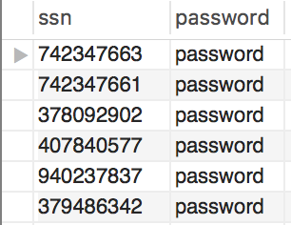

*Insert into registered_employee*

call insert_registered_employee('jj2196',742347663,'Joby','Joy','New York','Senior Engineer','Java Php','Dancing','Karl','A','jj2196@nyu.edu',x'C9CBBBCCCEB9C8CABCCCCEB9C9CBBB','Male','S');

call insert_registered_employee('gss383',742347661,'Gauri','Sarode','New York','Senior Engineer','Python Php','Movies','Karl','A','gss383@nyu.edu',x'C9CBBBCCCEB9C8CABCCCCEB9C9CBBB','Female','P');

call insert_registered_employee('pns234',378092902,'Pranav','Reddy','Bayridge','Data Engineer','Java React','Mingling','Gauri','B','pns23@nyu.edu',x'C9CBBBCCCEB9C8CABCCCCEB9C9CBBB','Male','S');

call insert_registered_employee('akk198',407840577,'Arun','Kondani','Manhattan','Website developer','Python React','Cribbing','Gauri','B','akk198@nyu.edu',x'C9CBBBCCCEB9C8CABCCCCEB9C9CBBB','Male','P');

call insert_registered_employee('ryk123',940237837,'Rahul','Keswani','Long Island','Data Scientist','React Php','Coding','Pranav','C','ryk123@nyu.edu',x'C9CBBBCCCEB9C8CABCCCCEB9C9CBBB','Male','S');

call insert_registered_employee('gpn967',379486342,'Geetesh','Nikhade','Boston','Full stack developer','Python Java','Drinking','Pranav','C','gpn967@nyu.edu',x'C9CBBBCCCEB9C8CABCCCCEB9C9CBBB','Male','P');

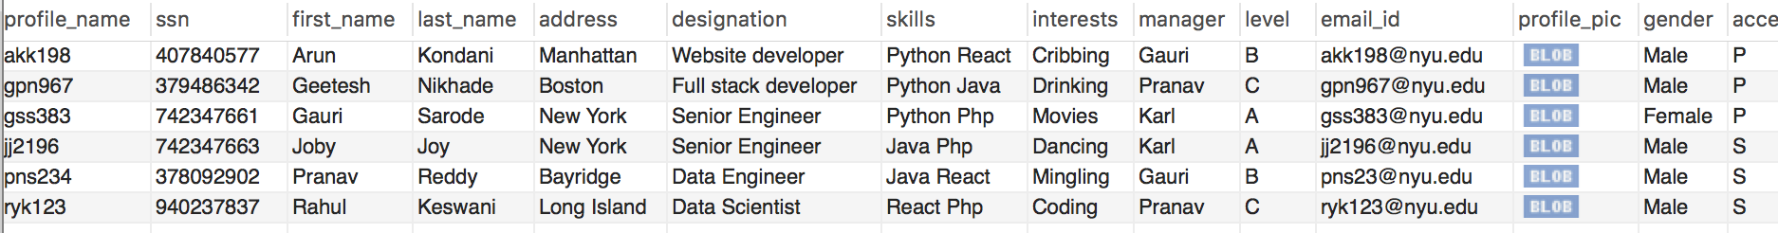

*Insert into post*

call insert_post('post_1','2010-07-22 22:30:12','First post','Day one it is!',' ');

call insert_post('post_2','2010-08-01 13:30:32','Second post','Some day it is!',' ');

call insert_post('post_3','2010-08-10 20:30:17','Third post','Not just another it is!',' ');

call insert_post('post_4','2010-09-20 04:30:29','Fourth post','So much work such little time!',' ');

call insert_post('post_5','2010-09-22 12:30:30','Fifth post','In the intense meeting discussion!',' ');

call insert_post('post_6','2010-10-02 12:20:43','Sixth post','Had the best curly fries ever!',' ');

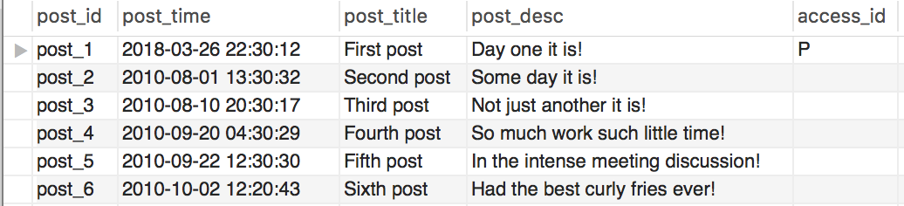

*Insert into wall*

call add_to_wall('post_1','jj2196');

call add_to_wall('post_2','gss383');

call add_to_wall('post_3','jj2196');

call add_to_wall('post_4','gss383');

call add_to_wall('post_5','gss383');

call add_to_wall('post_6','ryk123');

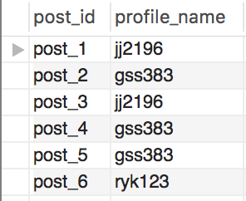

*Insert into relationship*

call insert_relationship('jj2196','gss383','T','2010-07-22 22:30:12','Accepted');

call insert_relationship('jj2196','ryk123','T','2012-07-22 22:30:12','Sent');

call insert_relationship('jj2196','akk198','F','2013-07-22 22:30:12','Declined');

call insert_relationship('jj2196','pns234','F','2010-07-22 22:30:12','Accepted');

call insert_relationship('gss383','pns234','T','2010-07-22 22:30:12','Accepted');

call insert_relationship('ryk123','gss383','T','2010-07-22 22:30:12','Sent');

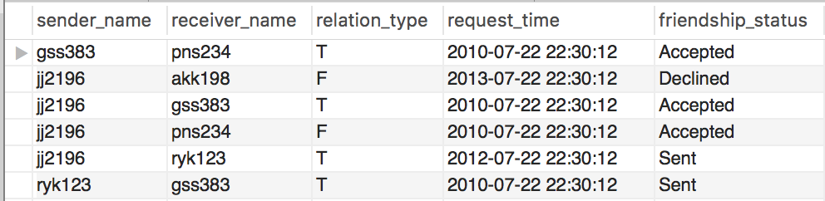

*Insert into multimedia_content*

call insert_multimedia('mul_1','post_1','Miami Image','jpg',x'C9CBBBCCCEB9C8CABCCCCEB9C9CBBB','S');

call insert_multimedia('mul_2','post_2','Florida image','jpg',x'C9CBBBCCCEB9C8CABCCCCEB9C9CBBB','P');

call insert_multimedia('mul_3','post_1','Sunset beach','jpg',x'C9CBBBCCCEB9C8CABCCCCEB9C9CBBB','F');

call insert_multimedia('mul_4','post_3','Curly fries','jpg',x'C9CBBBCCCEB9C8CABCCCCEB9C9CBBB','S');

call insert_multimedia('mul_5','post_1','Miami Image','jpg',x'C9CBBBCCCEB9C8CABCCCCEB9C9CBBB','P');

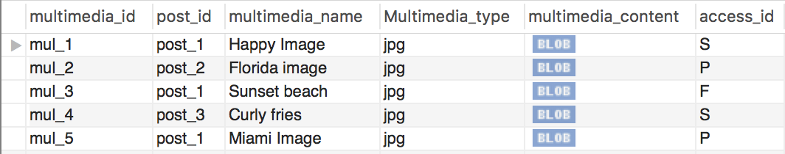

*Insert into comment*

call insert_comments('cmnt_1','post_3','So cool!','2010-07-22 22:30:12','gss383','P');

call insert_comments('cmnt_2','post_4','Let me join in','2010-09-21 04:30:29','ryk123','F');

call insert_comments('cmnt_3','post_5','Where is this!','2010-09-22 15:30:30','ryk123','F');

call insert_comments('cmnt_4','post_5','How does this work?','2010-09-23 12:30:302','gpn967','P');

call insert_comments('cmnt_5','post_5','Nice post man','2010-09-24 22:30:30','jj2196','P');

call insert_comments('cmnt_6','post_2','Isnt it there already?','2010-09-25 12:30:30','jj2196','F');

call insert_comments('cmnt_7','post_1','How was your conference?','2010-09-23 12:30:30','gpn967','P');

call insert_comments('cmnt_8','post_1','Its good to see you here. We should meet','2010-09-24 22:30:30','jj2196','P');

call insert_comments('cmnt_9','post_1','When is the conference?','2010-09-25 12:30:30','gss383','P');

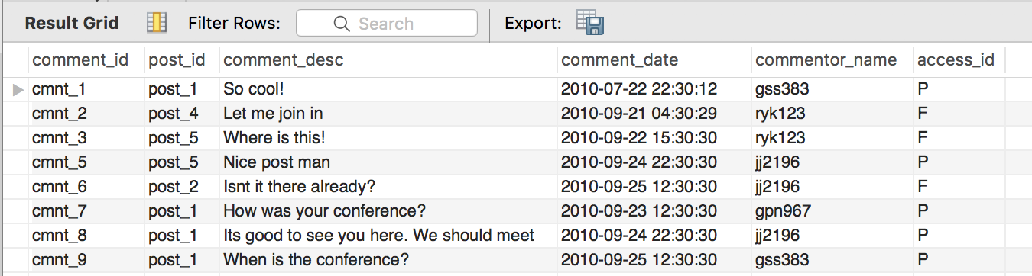

*Insert into location*

call insert_locations('loc_1','post_1','Miami Convention Center','Conference on AI for next generations','40.7587° N', '73.9787° W','P');

call insert_locations('loc_2','post_2','Wall Street','Meeting for a tender passing','42.7217° N', '34.9787° W','F');

call insert_locations('loc_3','post_3','Bobst Washington people','Conference for product deployment','78.7587° S', '13.9787° E','P');

call insert_locations('loc_4','post_4','Android robotic palace','Making aurduino work','30.7587° E', '23.9787° S','F');

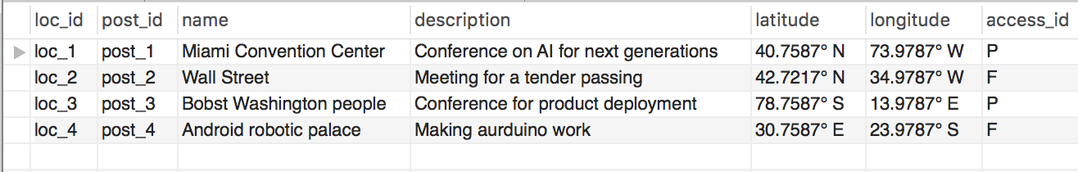

*Insert into likes*

call insert_likes('like_1','post_1','mul_1','cmnt_1',NULL,'gss383','2010-07-22 22:30:12');

call insert_likes('like_2','post_2','mul_1','cmnt_1',NULL,'akk198','2010-08-12 16:45:45');

call insert_likes('like_3','post_1','mul_1','cmnt_1',NULL,'akk198','2010-09-14 18:20:23');

call insert_likes('like_4','post_2','mul_1','cmnt_1',NULL,'pns234','2010-09-22 19:35:19');

call insert_likes('like_5','post_2','mul_2','cmnt_1',NULL,'pns234','2010-09-22 19:35:19');

call insert_likes('like_6','post_3',NULL,NULL,NULL,'pns234','2010-09-22 19:35:19');

call insert_likes('like_7','post_2','mul_2','cmnt_2',NULL,'pns234','2010-09-22 19:35:19');

call insert_likes('like_8','post_2','mul_1',NULL,NULL,'pns234','2010-09-22 19:35:19');

call insert_likes('like_9','post_4','mul_1',NULL,NULL,'pns234','2010-09-22 19:35:19');

call insert_likes('like_10','post_2','mul_3','cmnt_1',NULL,'pns234','2010-09-22 19:35:19');

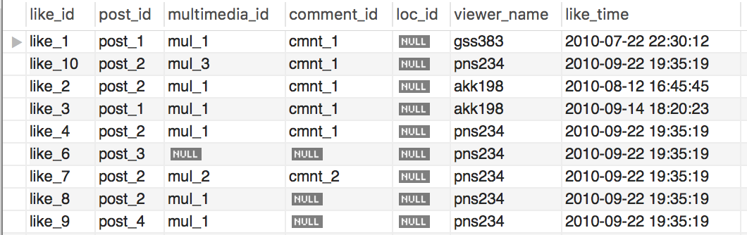

**Views:**

**#Display Posts by all the users**

CREATE OR REPLACE VIEW All_Posts_view AS

SELECT post_id, first_name as Name

FROM wall as w natural join registered_employee as re

where w.profile_name=re.profile_name;

select * from All_Posts_view;

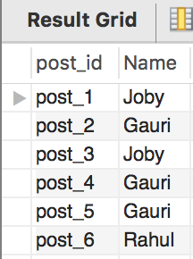

*Posts by a user:*

select post_id AS posts

from All_Posts_view

where Name='Gauri';

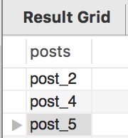

**#Display Multimedia Contents of a specific location**

CREATE OR REPLACE VIEW Multimedia_list_view AS

select m.multimedia_name as Name,m.Multimedia_type as Type,m.multimedia_content as Content

from multimedia_content as m, location as l

where l.post_id=m.post_id and l.name like '%Miami%' and (m.access_id='P' or m.access_id='F');

select * from Multimedia_list_view;

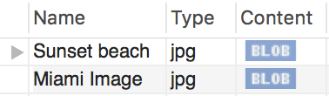

**#Display friends list of any User.**

Create OR Replace VIEW friendlist_view AS

select first_name as Friend,friendship_status as Status, request_time as Time

from relationship as r,registered_employee as e

where r.receiver_name=e.profile_name and r.sender_name = 'jj2196';

**Queries:**

These queries were created to check for different features of the Mingle application:

*Check for connections between two users*

select friendship_status as Status, request_time as Time

from relationship as r

where r.sender_name = 'jj2196' AND r.receiver_name='gss383';

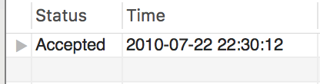

*Display friends list of any User.*

select first_name as Friend,friendship_status as Status, request_time as Time

from relationship as r,registered_employee as e

where r.receiver_name=e.profile_name and r.sender_name = 'jj2196';

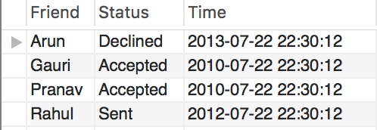

*Display friends list by connection request status.*

select *

from friendlist_view

where Status='Sent';

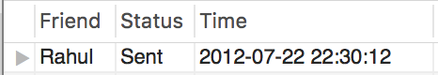

*Count Total likes by post for specific user*

select l.post_id as Post,count(l.post_id) as Like_Count

from likes as l natural join wall as w

where w.profile_name='jj2196'

group by l.post_id;

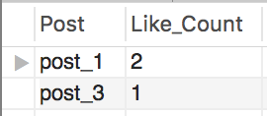

*Filter post by date*

select post_title,post_desc

from post

where post_time between date_sub(now(), interval 10 year )

and date(now()) ;

